**Final Website Proposal**

Monica Harwood

CMST 385 6381

Principles of Web Design & Technology I

1. **For Client:**

Monica Harwood (myself)

1. **Project Title:**

“*Black Water*” the Opera Informational Website

1. **Purpose:**

* The website provides general information about an upcoming performance of “*Black Water*,” including:
  + Performance dates and ticket purchase information
  + Synopsis
  + Audio and/or video samples
  + The inspiration behind the project (the book, “Black Water” as well as the historical event in Chappaquiddick)
  + Biographical information on the composer
  + Biographical information on the performers
  + News updates
  + Social Media

1. **Audience**
   * The primary audience of this website are the judges of the D.C. Capital Fringe Festival, who will be viewing the website in order to assess the production and determine whether it should be accepted as a part of the festival. These judges are experienced performing artists with established careers in arts entrepreneurship in the D.C. area. They will be interested in a website that is creative and unique, yet that functions as an effective marketing tool that will draw patrons to the festival.
   * The secondary audience of this website are patrons who are interested in attending the opera’s performance. These individuals are residents of the D.C. area over the age of 18, who already hold some interest in the arts and are eager to see and learn about new and original performances.
2. **Goals:**
   * The website will function as a supplemental application for the Washington, D.C. Capital Fringe Festival, by offering video/audio samples and more insight into the opera.
     1. The Fringe Festival judges will be able to easily access the website with a URL link, where they can view media materials and assess the validity of the project. This will result in the acceptance of the show into the Fringe Festival 2017.

* The website will facilitate fundraising for the project’s initiation.
  + 1. Upon acceptance in the Fringe Festival, the opera company will be responsible for approximately $800 in venue fees. This website will supplement fundraising by increasing the opera’s visibility and providing detailed information about the project, which will cover the cost of performance fees.
  + The website will generate ticket sales by digitally marketing the performances.
    1. Show dates, times, and a valid link to ticket purchasing information will make it easy for patrons to purchase tickets online.
    2. Projected sales through this site: 10 tickets per show (for 4 shows = 40 ticket sales).
  + The website will generate social media followers.
    1. Facebook, Twitter and YouTube links will be prominently displayed.
    2. Projected followers through social media: 20 on Facebook and 20 on Twitter
  + The website will offer up-to-date news and information about the performances.
    1. The website will need to be updated regularly in order to provide current show information.

1. **Site Map**
2. **Wireframes**
   * + 1. **Landing Page**

Layout: One-column, featuring a prominent title of the opera, captivating image, and button to enter site

[Button to Enter]

BLACK WATER

* + - 1. **Home Page**

Layout: Two-column, with header that contains nav bar, footer that contains social media tags and contact information. The title will be aligned left, and the nav elements will be aligned right. The footer contents will be aligned horizontally. Based on the rule of thirds, a focal point/image will be left-aligned towards the bottom.

[Title] Nav1 Nav2 Nav3 Nav4 Nav5

[About]

Some text about.

[Learn more]

Some text about.

[Tickets]

Some text for tickets.

[Footer]

[Social Media Links]

1. **Content**
   * **Text:**
     + - * 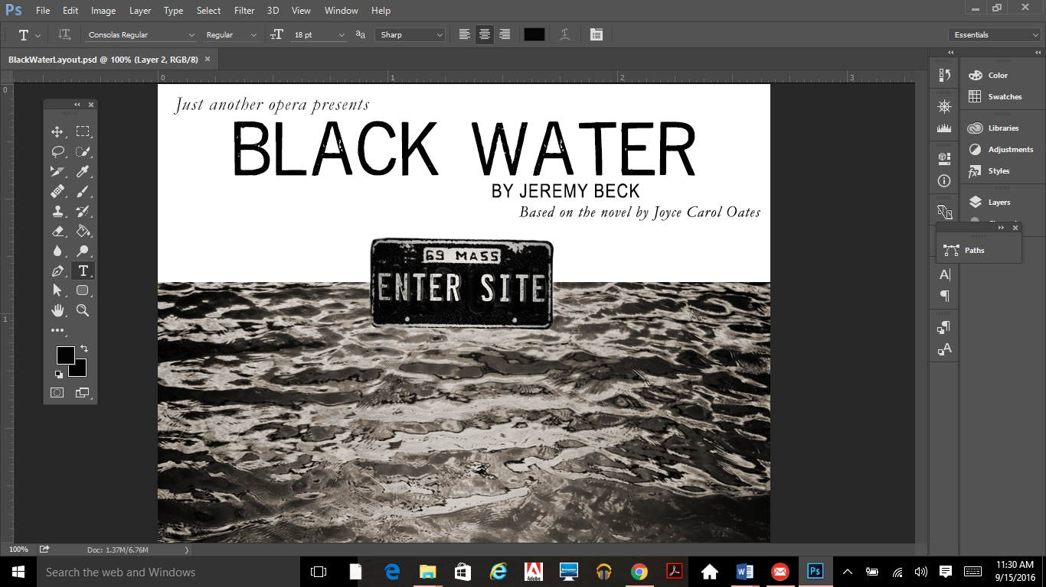The title, “Black Water” will be in “Reprise Stamp” font, each time that it is featured:
         * To contrast this, smaller titles or descriptions will be in Garamond Italic:
         * Since these fonts may not display correctly in different browsers, I will use PNG images for the main titles.
         * Body content will be in a legible serif font, that reflects the style of a newspaper from 1969, such as Times New Roman:

The opera is based on true incidents that occurred during the summer of 1969, on the island of Chappaquiddick, which is part of Martha’s Vineyard off the coast of Massachusetts. A popular vacation…

* **Images:**
  + I will use a stock image of water for the landing page image, which I will desaturate in Photoshop in order to portray “black” water.
  + I will use an image of a 1969 license plate that will function as the “Enter Site” button on the landing page, which I can retrieve from a historical website.
  + The image on the homepage will be a picture of the dock in Chappaquiddick, or some depiction of a beach near Martha’s Vineyard.
  + Under the biographical pages for the composer and performers, I will request to use headshot images along with verified bio’s.
  + On the “News” page, I will format the images and page like a newspaper from 1969, with columns, clear headings.
* **Colors:**
  + I will use predominantly black and off-white, to reflect the “1969 newspaper” feel. Images will provide contrasting bursts of color.

1. **Growth Potential**
   * While the website will be used primarily for advertising a limited-run performance, it would benefit from web hosting and a domain name. It also has the potential to grow:
     1. The composer has noted that he will provide links to my performance information, in order to enhance visibility of the performance. The composer may be interested in using the website as a template for other works.
     2. Timeline for updates/maintenance
        1. After Fringe Festival Submission (late October 2016)- text will be added to the “News” page
        2. Upon acceptance in Festival (February 2017)- text will be added to the “News” page,
        3. During Fundraising Campaign (February-May 2017)- social media updates, providing links to the website will need to be promoted bi-weekly
        4. Upon completion of fundraising (May 2017)- one social media update, as well as text added to the “News” section will be added
        5. Once performance dates/venues have been announced (June 2017)- performance dates/ticketing links will be added to respective pages
        6. During performance run with reviews (July 2017)- text will be added to the “News” page, social media updates as reviews are posted
        7. Upon culmination of performance (August 2017)- text will be added to the “News” page, social media updates will be posted
     3. **Ways to make updates easier:**
        1. Utilizing a Twitter bot, which will automatically post social media updates according to new information posted on the “News” page
        2. Maintaining a central CSS stylesheet for the basic color palette, fonts, and layouts, so that each page will have a consistent theme.